# Lab: Introduction to HTML and CSS

## Welcome to HTML

Create a Web Page like the following.

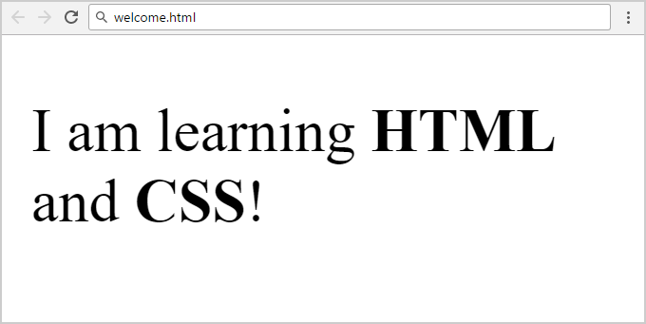

Create "**welcome.html**" document.

### Constraints

* Change the title
* Use paragraph tag for plain text and strong tag for bold text